AI-BASED THREAT INTELLIGENCE DASHBOARD
A Prototype System for Regional Activity Monitoring, Anomaly Detection, and AI-Assisted Reporting
An Internship Report
Submitted in partial fulfilment of the requirements of the
Def-Space Summer Internship 2026
Submitted by
Sagnik Bachhar
Applicant ID: BSERC-01258
Department of Computer Science & Engineering
Adamas University, Kolkata
Internship Organization
Bharat Space Education Research Centre (BSERC)
Internship Duration: 19 June 2026 – 30 July 2026

Certificate of Completion
This is to certify that the internship project titled “AI-Based Threat Intelligence Dashboard” was carried out by Sagnik Bachhar (Applicant ID: BSERC-01258), a student of the Department of Computer Science & Engineering, Adamas University, Kolkata, during the period 19 June 2026 to 30 July 2026, under the Def-Space Summer Internship 2026 programme conducted by the Bharat Space Education Research Centre (BSERC).
The work presented in this report is a bona fide record of the project work carried out by the candidate under the guidance of the undersigned, towards partial fulfilment of the internship requirements.
________________________
[Mentor / Guide Name]
Designation: [Mentor Designation]
Bharat Space Education Research Centre (BSERC)
________________________
[Head of Department / Institute Coordinator]
Department of Computer Science & Engineering
Adamas University, Kolkata
Date: _______________ Place: Kolkata

Declaration
I, Sagnik Bachhar, hereby declare that the internship report entitled “AI-Based Threat Intelligence Dashboard” submitted to the Department of Computer Science & Engineering, Adamas University, Kolkata, in partial fulfilment of the requirements of the Def-Space Summer Internship 2026 conducted by the Bharat Space Education Research Centre, is a record of original work carried out by me during the period 19 June 2026 to 30 July 2026.
I further declare that this report, or any part of it, has not been submitted elsewhere for the award of any degree, diploma, or certificate, and that all sources of information used in the preparation of this report have been duly acknowledged.
________________________
Sagnik Bachhar
Applicant ID: BSERC-01258
Department of Computer Science & Engineering
Adamas University, Kolkata

Acknowledgement
I would like to express my sincere gratitude to the Bharat Space Education Research Centre (BSERC) for providing me the opportunity to undertake this internship as part of the Def-Space Summer Internship 2026 programme. This experience has given me valuable exposure to real-world software architecture, AI-oriented system design, and the practical challenges of building full-stack data applications.
I am deeply thankful to my mentor, [Mentor Name], for their continuous guidance, technical insights, and encouragement throughout the course of this project. Their feedback was instrumental in shaping both the direction and the quality of this work.
I would also like to thank the faculty of the Department of Computer Science & Engineering, Adamas University, Kolkata, for their academic support and for encouraging me to pursue this internship opportunity.
Finally, I extend my appreciation to my family and peers for their constant support and motivation during this internship period.
Sagnik Bachhar

Abstract
Modern situational-awareness and monitoring systems increasingly rely on dashboards that combine geospatial visualization, time-series analytics, and machine-learning-driven insight generation into a single interface. This report documents the design and implementation of a prototype “AI-Based Threat Intelligence Dashboard”, developed during a summer internship with the Bharat Space Education Research Centre (BSERC) under the Def-Space Summer Internship 2026 programme.
The system was built in three progressive phases. The first phase delivered an interactive Streamlit-based dashboard featuring a Folium-powered world map, KPI cards, activity-trend charts, threat-level distribution charts, an alert feed, and a template-generated AI intelligence summary, all driven by a synthetic data-generation module. The second phase introduced a persistent data layer: a FastAPI backend exposing REST endpoints for regions, trends, alerts, and model metadata, backed by a PostgreSQL database accessed through SQLAlchemy ORM models, with the frontend automatically falling back to local synthetic data whenever the API is unreachable. The third, forward-looking phase outlines the integration plan for real machine-learning models — Random Forest and XGBoost for classification, LSTM for activity forecasting, Isolation Forest for anomaly detection, BERT for report-text analysis, and YOLOv8 for satellite-imagery object detection — to replace the current simulated model-performance figures with genuine trained models.
The resulting prototype demonstrates a complete, deployable full-stack architecture (Streamlit, FastAPI, PostgreSQL) and was successfully deployed to Streamlit Community Cloud for public access and evaluation. Importantly, all data used throughout the current prototype is synthetically generated; the system is explicitly designed and documented as a demonstration architecture rather than an operational intelligence tool, and does not connect to any real satellite, sensor, or classified data source. This report details the objectives, system design, implementation, testing, deployment process, challenges encountered, and the roadmap for future enhancement of the system.
Keywords: Threat Intelligence Dashboard, Streamlit, FastAPI, PostgreSQL, Synthetic Data, Anomaly Detection, Machine Learning, System Architecture, Full-Stack Development.

Table of Contents
Certificate of Completion 2
Declaration 3
Acknowledgement 4
Abstract 5
List of Figures 7
List of Abbreviations 8
Chapter 1: Introduction 9
Chapter 2: Literature Survey / Related Work 11
Chapter 3: System Requirements 12
Chapter 4: System Design and Architecture 13
Chapter 5: Implementation 16
Chapter 6: Testing 18
Chapter 7: Results and Discussion 19
Chapter 8: Challenges Faced 20
Chapter 9: Conclusion and Future Scope 21
References 22
Appendix 23

List of Figures
Figure 4.1: System Architecture Diagram
Figure 4.2: Database Entity-Relationship Diagram
Figure 4.3: Data Flow Diagram — Request Lifecycle
Figure 7.1: Dashboard Home View (Map, KPIs, Alerts)
Figure 7.2: FastAPI Interactive Documentation (Swagger UI)

List of Abbreviations
Abbreviation | Full Form
AI | Artificial Intelligence
API | Application Programming Interface
BSERC | Bharat Space Education Research Centre
CRUD | Create, Read, Update, Delete
CSS | Cascading Style Sheets
CV | Computer Vision
DB | Database
ER Diagram | Entity-Relationship Diagram
JSON | JavaScript Object Notation
KPI | Key Performance Indicator
LSTM | Long Short-Term Memory (neural network)
NLP | Natural Language Processing
ORM | Object-Relational Mapping
REST | Representational State Transfer
SQL | Structured Query Language
UI/UX | User Interface / User Experience
YOLO | You Only Look Once (object detection model)

Chapter 1: Introduction

1.1 About the Organization
The Bharat Space Education Research Centre (BSERC) is an organization focused on space and defence-technology education, research, and technology-transfer programmes in India. BSERC conducts workshops, training programmes, and internships spanning areas such as rocketry, drone and aircraft-design technology, cybersecurity, and emerging defence technologies, in alignment with national initiatives such as Viksit Bharat @2047 and Atmanirbhar Bharat. As part of these efforts, BSERC runs the Def-Space Summer Internship programme, which gives students hands-on exposure to project-based work in space and defence-adjacent technology domains.

1.2 Motivation and Background
Modern monitoring and situational-awareness systems, whether used in defence, disaster response, logistics, or infrastructure security, increasingly depend on dashboards that fuse multiple types of data — geospatial positions, time-series trends, categorical risk levels, and free-text summaries — into a single, interpretable interface. Building such a system end-to-end requires competency across several layers of the modern software stack: an interactive frontend for visualization, a backend service layer for business logic, a persistent database for storage, and increasingly, machine-learning models for prediction and anomaly detection.
This internship project was undertaken to design and build a working prototype of such a system — a Threat Intelligence Dashboard — as a practical exercise in full-stack application development combined with an architectural roadmap for AI/ML integration. Rather than attempting to source or process real classified or operational intelligence data (which is neither appropriate nor accessible in an academic internship context), the project deliberately uses synthetically generated data throughout, while building all of the surrounding architecture — frontend, backend, database, and API layer — to production-grade patterns that would support real data sources in a future iteration.

1.3 Problem Statement
Organizations that need to monitor distributed regional activity (for example, logistics networks, infrastructure sensors, or any set of geographically distributed data sources) typically require a dashboard that can: (a) visualize the current state of each monitored location on a map, (b) summarize risk or activity levels using clear indicators, (c) show how activity has trended over time, (d) surface anomalies or noteworthy events as alerts, and (e) provide a human-readable summary suitable for quick review. Building a system that satisfies all of these requirements, while remaining maintainable, testable, and deployable, is a non-trivial software engineering problem that this project set out to solve at a prototype scale.

1.4 Objectives of the Project
- To design and implement an interactive, map-based dashboard for visualizing regional activity and threat-level data.
- To build a REST API backend (FastAPI) that exposes this data through well-defined endpoints.
- To design and implement a relational database schema (PostgreSQL) to persist the data, replacing in-memory-only storage.
- To implement a synthetic data-generation module that produces realistic, clearly-labelled non-real data for development, testing, and demonstration.
- To document an architecture and roadmap for integrating real machine-learning models (classification, forecasting, anomaly detection, NLP, and computer vision) in a future phase.
- To deploy the working prototype to a publicly accessible hosting platform for demonstration and evaluation.

1.5 Scope of the Project
The scope of this internship project covers the design and implementation of the frontend dashboard, the backend API, the database schema, and the synthetic data pipeline, along with deployment of the system to a live hosting environment. The scope explicitly excludes the use of any real satellite imagery, sensor feeds, or classified/operational intelligence data; all data referenced or displayed by the system is synthetically generated for demonstration purposes. The integration of trained machine-learning models (Random Forest, XGBoost, LSTM, Isolation Forest, BERT, YOLOv8) is scoped as a documented roadmap for future work rather than a deliverable of the current internship period, given the time constraints of a six-week internship.

1.6 Report Organization
The remainder of this report is organized as follows. Chapter 2 reviews related work and existing approaches to dashboard-based monitoring systems. Chapter 3 specifies the hardware and software requirements and the technology stack chosen for the project. Chapter 4 presents the system design, including the architecture, database schema, and data-flow diagrams. Chapter 5 describes the implementation in detail, covering the frontend, backend, database layer, and synthetic data module. Chapter 6 discusses the testing methodology and results. Chapter 7 presents the results and deployment outcomes. Chapter 8 discusses the challenges encountered during development and deployment. Chapter 9 concludes the report and outlines the scope for future work.

Chapter 2: Literature Survey / Related Work

2.1 Dashboard-Based Monitoring Systems
Dashboard-based monitoring tools are widely used across domains such as network operations, business intelligence, disaster management, and public health surveillance. Common design patterns across these systems include a map or spatial visualization component, numeric key-performance-indicator (KPI) summaries, time-series trend charts, and an alert or notification feed that highlights anomalies or threshold breaches. Frameworks such as Streamlit, Dash (Plotly), and Grafana have popularized rapid development of such dashboards by abstracting away much of the frontend boilerplate historically required to build interactive data applications.

2.2 Machine Learning in Monitoring and Anomaly Detection
A range of machine-learning techniques are commonly applied to monitoring and threat-analysis problems. Tree-based ensemble methods such as Random Forest and XGBoost are frequently used for classification tasks (e.g., categorizing risk level from engineered features) due to their strong performance on structured/tabular data and relative ease of interpretation compared to deep-learning alternatives. Recurrent architectures such as Long Short-Term Memory (LSTM) networks are well suited to time-series forecasting problems, such as predicting future activity trends from historical sequences. Isolation Forest is a widely used unsupervised algorithm for anomaly detection, as it does not require labelled anomaly data and scales well to high-dimensional data. In the domain of unstructured data, transformer-based language models such as BERT are used for text classification and summarization tasks (relevant to automatically generating or classifying intelligence-style reports), while convolutional object-detection architectures such as the YOLO (You Only Look Once) family are used for real-time object detection in imagery, including satellite and aerial imagery analysis.

2.3 Full-Stack Architecture Patterns
A common and well-established architectural pattern for data-driven web applications separates the system into three layers: a presentation/frontend layer, an application/API layer, and a persistence/database layer. FastAPI has emerged as a popular choice for the API layer in Python-based systems due to its use of type-annotated Python and automatic generation of interactive API documentation (via the OpenAPI/Swagger specification). PostgreSQL is a widely adopted open-source relational database well suited to structured, relationally-linked data such as the region/snapshot/alert schema used in this project. SQLAlchemy is a mature Object-Relational Mapping (ORM) library that allows Python classes to map directly to database tables, reducing the amount of raw SQL required and improving maintainability.

2.4 Gaps Identified and Project Positioning
While many production monitoring dashboards exist commercially, few openly documented student/internship-level projects walk through the complete process of building such a system from a simple single-file prototype through to a persisted, API-backed, and deployed application, while being explicit and transparent about which parts use real versus synthetic data. This project is positioned specifically to fill that gap: it documents, at each phase, exactly what is implemented versus what remains a planned integration, which is a deliberate design choice intended to produce an honest and technically defensible piece of internship work.

Chapter 3: System Requirements

3.1 Hardware Requirements
Component | Minimum Specification
Processor | Dual-core CPU, 2.0 GHz or higher
RAM | 8 GB (16 GB recommended for local PostgreSQL + API + dashboard)
Storage | 1 GB free space for dependencies and project files
Network | Broadband internet connection (for package installation and deployment)
Display | 1366×768 or higher resolution recommended for dashboard viewing

3.2 Software Requirements
Software / Tool | Purpose
Python 3.10+ | Core programming language for frontend, backend, and data modules
Streamlit | Frontend dashboard framework
FastAPI | Backend REST API framework
Uvicorn | ASGI server used to run the FastAPI application
PostgreSQL 14+ | Relational database for persistent storage
SQLAlchemy | ORM layer connecting Python models to PostgreSQL
Plotly / Folium | Charting and interactive map rendering
Pandas / NumPy | Data manipulation and synthetic data generation
Git & GitHub | Version control and source hosting for deployment
Streamlit Community Cloud | Hosting platform for the deployed dashboard
Visual Studio Code | Development environment (IDE)

3.3 Technology Stack Overview
The technology stack was chosen to balance rapid prototyping with an architecture that mirrors real production systems. Python was selected as the single language across the entire stack (frontend, backend, and data layer) to minimize context-switching overhead during a time-constrained internship. Streamlit was chosen for the frontend because it allows building rich, interactive, data-centric interfaces directly in Python without requiring separate JavaScript/HTML/CSS development, which suited the project's emphasis on data and system architecture over UI engineering. FastAPI was chosen for the backend due to its strong typing support, automatic request validation via Pydantic, and automatically generated interactive documentation, all of which reduce the risk of integration bugs between frontend and backend. PostgreSQL was selected over lighter-weight alternatives (such as SQLite) specifically because it is the class of database used in real production deployments, making the resulting architecture directly extensible beyond the internship.

Chapter 4: System Design and Architecture

4.1 Overall System Architecture
The system follows a layered client-server architecture consisting of four principal components: the Streamlit frontend, an HTTP API-client layer, the FastAPI backend, and the PostgreSQL database. A synthetic data-generation module supports both the database seeding process and a local fallback mode, so that the dashboard remains fully functional even when the backend or database is not running — an important design decision for demonstration and grading purposes, where reviewers may not wish to set up a full database locally.
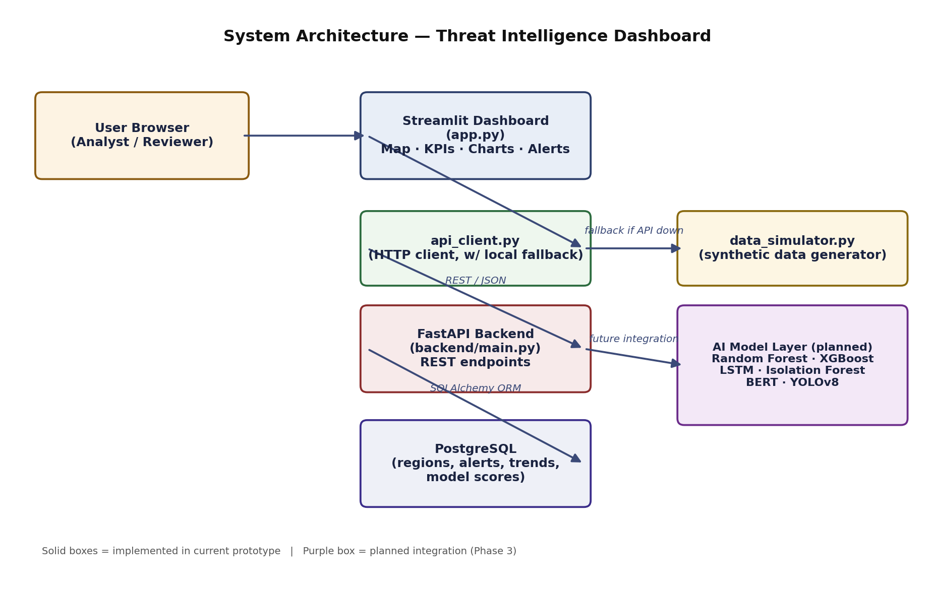
Figure 4.1: System Architecture Diagram

4.2 Database Design
The database schema consists of five tables. The regions table stores static metadata for each monitored region (name and coordinates). The region_snapshots table stores the latest known threat level, activity score, and confidence value for each region, linked to regions via a foreign key. The activity_trend_points table stores a time series of historical activity scores per region, supporting the 30-day trend chart. The alerts table stores individual simulated alert events, each linked to a region and tagged with the originating (simulated) model. The model_scores table stores performance metadata for each AI model referenced in the system, independent of any specific region.
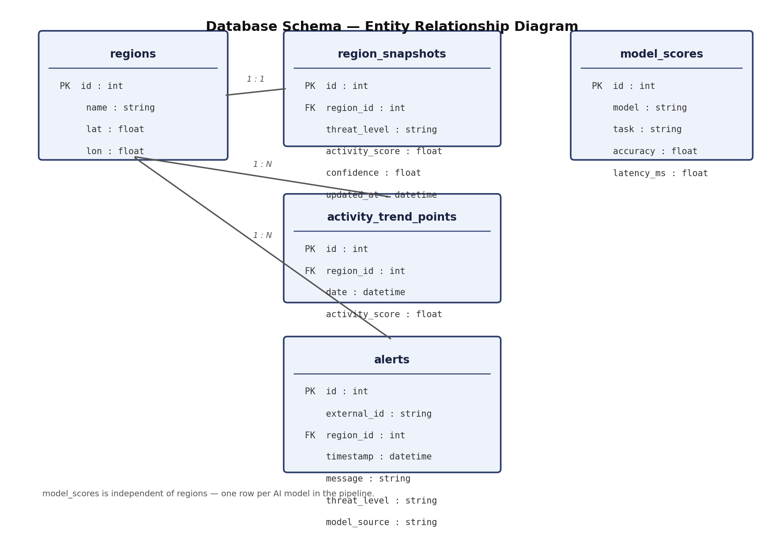
Figure 4.2: Database Entity-Relationship Diagram

4.3 Data Flow
On each dashboard load or refresh, the Streamlit frontend requests data through the api_client module, which issues HTTP GET requests to the FastAPI backend. The backend queries PostgreSQL through SQLAlchemy ORM models, validates and serializes the results using Pydantic schemas, and returns JSON responses. If the API is unreachable — for example, if only the frontend has been deployed without the backend — the api_client module transparently falls back to generating the same shaped data locally using the data_simulator module, and the sidebar indicates which data source is currently active.
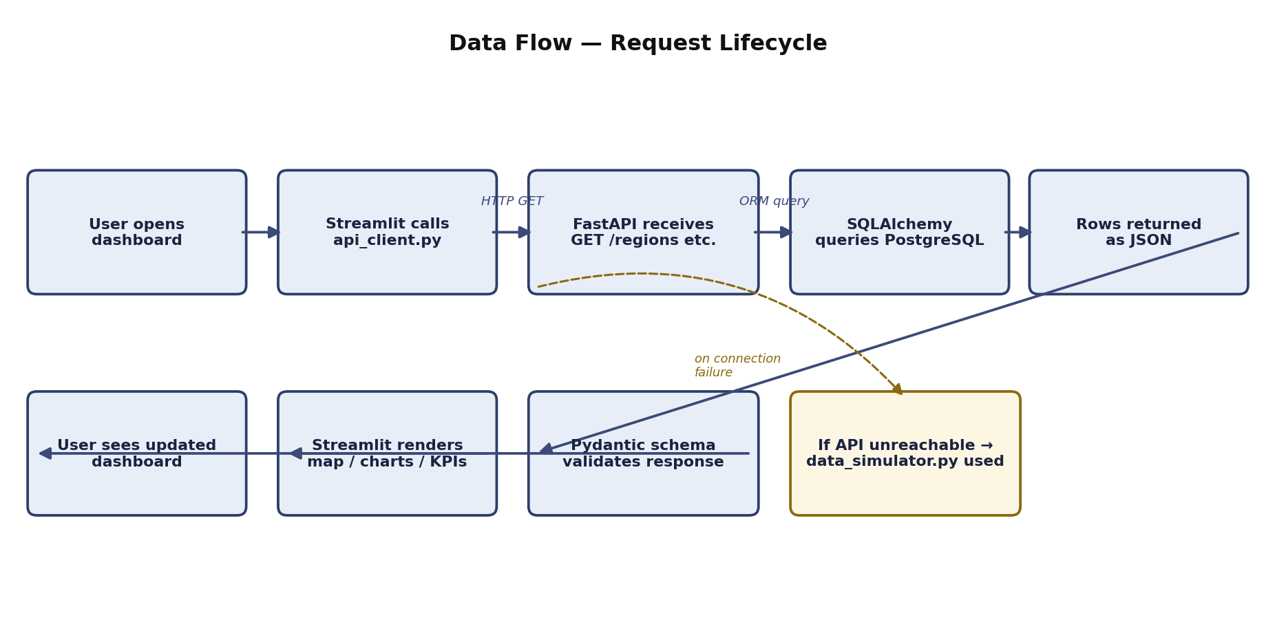
Figure 4.3: Data Flow Diagram — Request Lifecycle

4.4 Module Description
Module | Responsibility
app.py | Streamlit dashboard UI: map, KPI cards, charts, alert feed, AI report panel
api_client.py | HTTP client used by the frontend; falls back to local generation if API is down
data_simulator.py | Generates synthetic regions, trends, alerts, model scores, and text reports
backend/main.py | FastAPI application exposing REST endpoints
backend/models.py | SQLAlchemy ORM model definitions
backend/schemas.py | Pydantic response schema definitions
backend/database.py | Database engine/session configuration
backend/seed.py | Populates PostgreSQL with synthetic data

Chapter 5: Implementation

5.1 Frontend Implementation (Streamlit Dashboard)
The frontend was implemented in app.py using Streamlit. It includes a sidebar with region and threat-level filters, a manual data-refresh control, and a live indicator of which AI models are “active” in the pipeline. The main view is organized into a KPI row (monitored regions, active alerts, high/severe-threat region count, and average model confidence), an interactive Folium map with colour-coded markers sized by activity score, a tabular region snapshot, a 30-day activity-trend line chart (Plotly), a threat-level distribution bar chart, an AI model performance bar chart, a scrollable alert feed with colour-coded severity, and an AI-generated intelligence report panel.

5.2 Backend Implementation (FastAPI)
The backend was implemented in backend/main.py using FastAPI. Five REST endpoints were implemented: GET /regions (latest snapshot per region), GET /trends (optionally filtered by region), GET /alerts (most recent alerts, limit configurable), GET /models (AI model performance metadata), and GET /report (a template-generated textual summary derived from the current region snapshots). Each endpoint uses a SQLAlchemy session obtained via FastAPI's dependency-injection system and returns data validated against Pydantic response schemas, ensuring a stable, self-documenting contract between frontend and backend. FastAPI automatically generates interactive Swagger documentation at the /docs endpoint, which was used extensively during development and testing.

5.3 Database Layer (PostgreSQL + SQLAlchemy)
The database connection is configured through environment variables (POSTGRES_USER, POSTGRES_PASSWORD, POSTGRES_HOST, POSTGRES_PORT, POSTGRES_DB) read in backend/database.py, allowing the same code to run against a local development database or a cloud-hosted database without code changes. The seed.py script creates all tables (if they do not already exist) and populates them using the same generator functions used for local fallback, ensuring the seeded data and the fallback data are structurally identical.

5.4 Synthetic Data Generation Module
The data_simulator.py module is central to the project's approach to data. It generates eight illustrative, generically named monitoring regions (deliberately not tied to any real named location) and produces randomized but plausible values for threat level, activity score, and model confidence, using a fixed random seed for reproducibility. It also generates a 30-day historical activity trend per region using a randomized baseline and drift, a rotating set of simulated alert messages tagged with a randomly assigned “source model”, and a template-based (rule-based) natural-language report generator that summarizes the highest- and lowest-activity regions and the count of high/severe-threat regions. This module is explicitly documented, in code comments and in this report, as producing non-real, illustrative data only.

5.5 Planned AI Model Integration
At the current stage of the project, the “AI Models” shown in the sidebar and performance chart are represented by fixed, illustrative accuracy and latency figures rather than by trained models; no Random Forest, XGBoost, LSTM, Isolation Forest, BERT, or YOLOv8 model has yet been trained or integrated. This is deliberately and transparently documented rather than implied to be complete, both in the codebase and in this report. The intended integration path, to be pursued as future work, is as follows: an Isolation Forest model trained on the activity_trend_points time series to generate genuine anomaly-based alerts (replacing the current randomly selected alert messages); an LSTM model trained on the same time series to produce real short-horizon activity forecasts; a Random Forest or XGBoost classifier trained on engineered features (current activity score, rate of change, historical volatility) to predict threat level; a YOLOv8 model fine-tuned or applied out-of-the-box to openly licensed satellite imagery (e.g., Sentinel-2 via the Copernicus programme) for object detection; and a BERT-based text classifier to categorize or summarize open-source text reports feeding into the AI report panel.

5.6 Deployment
The project was version-controlled using Git and hosted on GitHub. The frontend was deployed to Streamlit Community Cloud by connecting the GitHub repository, selecting the main branch, and specifying app.py as the entry point; Streamlit Community Cloud automatically installs the dependencies listed in requirements.txt and provisions a public URL for the running application. Because the api_client module gracefully falls back to synthetic local data when no backend is reachable, the deployed dashboard is fully functional as a standalone frontend deployment even without a separately hosted backend and database, which was the deployment configuration used for project submission.

Chapter 6: Testing

6.1 Testing Approach
Testing was carried out at two levels. First, each backend REST endpoint was tested directly using command-line HTTP requests (curl) against a locally running instance of the FastAPI server backed by a freshly seeded PostgreSQL database, to verify correct status codes, response shapes, and error handling (for example, requesting trend data for a non-existent region correctly returns an HTTP 404 response). Second, the Streamlit frontend was tested manually by running it against both a live backend and, separately, with the backend stopped, to confirm that the local synthetic-data fallback activates correctly and that the sidebar accurately reflects the active data source in both cases.

6.2 Test Cases
ID | Test Case | Expected Result | Result
TC-01 | GET /regions with seeded database | Returns list of 8 region snapshots (HTTP 200) | Pass
TC-02 | GET /trends?region=<valid> | Returns time-series data for that region (HTTP 200) | Pass
TC-03 | GET /trends?region=<invalid> | Returns HTTP 404 with descriptive error | Pass
TC-04 | GET /alerts?limit=2 | Returns exactly 2 most recent alerts | Pass
TC-05 | GET /models | Returns 6 model score records | Pass
TC-06 | GET /report | Returns generated summary text with current timestamp | Pass
TC-07 | Dashboard with backend running | Sidebar shows “FastAPI + PostgreSQL” data source | Pass
TC-08 | Dashboard with backend stopped | Sidebar shows “Local synthetic generator” fallback | Pass
TC-09 | Region/threat-level filters | Map, table, and charts update to match selected filters | Pass
TC-10 | Deployment on Streamlit Community Cloud | Application builds and serves publicly without errors | Pass

6.3 Observations
All ten test cases listed above passed during manual verification. During early development, two notable issues were identified and resolved through testing: an initial mismatch between the column names returned by the API (updated_at) and those expected by the frontend (last_updated), which was resolved by normalizing the column name inside api_client.py; and a Streamlit API deprecation warning (use_container_width) which was resolved by migrating to the newer width parameter for native Streamlit components while retaining the older parameter for the third-party streamlit-folium map component, which has not yet adopted the new API.

Chapter 7: Results and Discussion

7.1 Summary of Outcomes
The internship produced a fully functional, three-tier prototype system: an interactive Streamlit dashboard, a FastAPI REST backend, and a PostgreSQL persistence layer, connected by a resilient API client with automatic fallback to synthetic data. The system was successfully deployed to Streamlit Community Cloud and is publicly accessible for review. All planned Phase 1 and Phase 2 objectives (interactive dashboard; backend + database data layer) were completed and verified through manual and endpoint-level testing.

7.2 Dashboard Functionality
The deployed dashboard displays eight illustrative monitoring regions on an interactive dark-themed world map, with marker size and colour reflecting simulated activity score and threat level respectively. KPI cards summarize the count of monitored regions, active alerts, high/severe-threat regions, and average model confidence. A 30-day trend chart shows simulated activity scores per region, alongside a threat-level distribution chart and an AI-model performance chart. A scrollable, colour-coded alert feed and a template-generated textual intelligence summary complete the interface. All filtering (by region and threat level) is reflected consistently across the map, table, charts, and alert feed.

7.3 API Documentation
The FastAPI backend automatically exposes interactive Swagger UI documentation at the /docs endpoint, allowing every REST endpoint to be inspected and tested directly from a browser without additional tooling. This proved valuable both for development-time testing and as a self-documenting artifact of the API's contract.

7.4 Honest Assessment of Current Limitations
It is important to state clearly what the current system does and does not do. The system does not connect to any real satellite imagery, sensor network, or intelligence source; all displayed data is synthetically generated by data_simulator.py. The “AI models” referenced in the interface are represented by static, illustrative performance figures; no model has yet been trained on real or synthetic data to produce the predictions shown. These limitations are by design, given the academic and time-constrained nature of the internship, and are documented transparently throughout this report and the project's own README file, rather than being presented as complete capabilities.

Chapter 8: Challenges Faced

8.1 Environment and Execution Issues
A recurring early challenge was correctly invoking the Streamlit application. Running the script directly with the Python interpreter (python app.py) produces a “missing ScriptRunContext” warning and does not start the Streamlit server, because Streamlit applications must be executed through the Streamlit CLI (streamlit run app.py) or, where the streamlit command is not on the system PATH, via python -m streamlit run app.py. This was traced, in one instance, to VS Code's built-in “Run Python File” button, which always invokes the plain Python interpreter regardless of the file's actual entry point, and was resolved by running the correct command manually from the integrated terminal.

8.2 API Deprecation Handling
During development, Streamlit issued a deprecation warning for the use_container_width parameter, scheduled for removal after 31 December 2025, in favour of a new width parameter. This was addressed for native Streamlit components (charts and dataframes), but the third-party streamlit-folium map component was found, on inspection of its function signature, to still require the older use_container_width parameter, illustrating the general challenge of managing API evolution across a dependency graph that updates at different rates.

8.3 Hosting Platform Selection
An initial attempt was considered to deploy the application on Vercel, a platform optimized for static sites and short-lived serverless functions. This was identified as fundamentally incompatible with Streamlit's execution model, which requires a persistent, stateful server process maintaining WebSocket connections to the browser. Streamlit Community Cloud was identified as the appropriate, purpose-built hosting platform for this class of application, and deployment was completed successfully once the correct entry-point filename (app.py, rather than the platform's default suggestion of streamlit_app.py) was specified in the deployment configuration.

8.4 Maintaining Data-Source Consistency
Because the system supports two possible data sources — the live FastAPI/PostgreSQL backend and the local synthetic-data fallback — care was required to ensure both paths produced data with identical column names and types, so that the same frontend rendering code could consume either source without branching logic. This was solved by normalizing field names (for example, mapping the API's updated_at field to the last_updated field name expected by the frontend) inside the api_client module.

Chapter 9: Conclusion and Future Scope

9.1 Conclusion
This internship project successfully delivered a working, deployed, three-tier prototype of an AI-oriented threat-intelligence dashboard, covering frontend visualization, backend API design, relational database modelling, and cloud deployment. The project deliberately prioritized architectural correctness, transparency about the synthetic nature of its data, and a clear, documented roadmap for future machine-learning integration over premature or superficial claims of AI capability. In doing so, it provided substantial hands-on experience across the full modern web-application stack — Streamlit, FastAPI, SQLAlchemy, and PostgreSQL — as well as practical experience in dependency management, API design, environment configuration, and cloud deployment.

9.2 Future Scope
- Train and integrate an Isolation Forest model on the activity_trend_points time series to generate genuine, data-driven anomaly alerts.
- Train an LSTM model to forecast future activity scores, replacing the currently randomized trend generation.
- Train a Random Forest or XGBoost classifier on engineered features to predict threat level from historical patterns.
- Integrate a YOLOv8 model applied to openly licensed satellite imagery (e.g., Sentinel-2 via Copernicus) for object-detection-based activity indicators.
- Integrate a BERT-based text classifier or summarizer to generate the AI intelligence report from real open-source text inputs rather than a fixed template.
- Deploy the FastAPI backend and PostgreSQL database to a managed cloud platform (e.g., Render or Railway) so that the fully live, persisted version of the system is publicly accessible alongside the frontend.
- Add authentication and role-based access control, given that any future integration of real (even if non-classified) data sources would necessitate access control.
- Add a historical playback slider to the map to allow reviewing how regional activity evolved over time.
- Add PDF export of the AI-generated intelligence report for offline sharing.

References
Streamlit Inc. “Streamlit Documentation.” https://docs.streamlit.io
FastAPI. “FastAPI Documentation.” https://fastapi.tiangolo.com
PostgreSQL Global Development Group. “PostgreSQL Documentation.” https://www.postgresql.org/docs/
SQLAlchemy. “SQLAlchemy ORM Documentation.” https://docs.sqlalchemy.org
Plotly Technologies Inc. “Plotly Python Graphing Library.” https://plotly.com/python/
streamlit-folium. “streamlit-folium Documentation.” https://github.com/randyzwitch/streamlit-folium
Breiman, L. “Random Forests.” Machine Learning, 45(1), 2001.
Chen, T. & Guestrin, C. “XGBoost: A Scalable Tree Boosting System.” KDD, 2016.
Hochreiter, S. & Schmidhuber, J. “Long Short-Term Memory.” Neural Computation, 9(8), 1997.
Liu, F. T., Ting, K. M., & Zhou, Z.-H. “Isolation Forest.” ICDM, 2008.
Devlin, J., Chang, M.-W., Lee, K., & Toutanova, K. “BERT: Pre-training of Deep Bidirectional Transformers for Language Understanding.” NAACL, 2019.
Jocher, G. et al. “YOLOv8 Documentation.” Ultralytics, https://docs.ultralytics.com
Bharat Space Education Research Centre. “Def-Space Summer Internship 2026.” https://bserc.org
Copernicus Open Access Hub. “Sentinel-2 Mission.” European Space Agency, https://sentinel.esa.int

Appendix

A. Project Repository and Deployment Links
- Source code repository: [GitHub repository URL]
- Live deployed dashboard: https://threat-intelligence-dashboard-fgtpmacqn7587z9qspvqmp.streamlit.app/
- FastAPI interactive documentation (when backend is run locally): http://localhost:8000/docs

B. Key Project Files
File | Description
app.py | Main Streamlit dashboard application
api_client.py | API client with local-fallback logic
data_simulator.py | Synthetic data generation module
requirements.txt | Python dependency list
backend/main.py | FastAPI application and REST endpoints
backend/models.py | SQLAlchemy ORM models
backend/schemas.py | Pydantic response schemas
backend/database.py | Database engine/session configuration
backend/seed.py | Database seeding script

C. Sample API Response — GET /report
{
"report": "**Daily Synthetic Intelligence Summary — 2026-07-28 19:50 UTC**\n\n- Monitored regions: 8\n- Regions at High/Severe threat level: 2\n- Highest activity: Region C — Coastal Zone ...",
"generated_at": "2026-07-28T19:50:12.451Z"
}

